**Cmocka**

Unit testing framework

Cmocka is an elegant unit testing framework for C with support for mock objects. It only requires the standard C library, works on a range of computing platforms (including embedded) and with different compilers.

Official Website: https://cmocka.org

**How to install:**

This library is available for both Windows and Linux.

For LINUX:

* First download [cmocka-1.1.0.tar.xz](https://cmocka.org/files/1.1/cmocka-1.1.0.tar.xz)
* Install it using the following commands

$ cd ~/Downloads

$ xz –d cmocka-1.1.0.tar.xz

$ tar vxf cmocka-1.1.0.tar

$ cd cmocka-1.1.0

$ mkdir build

$ cd build

$ cmake -DCMAKE_INSTALL_PREFIX=/usr -DCMAKE_BUILD_TYPE=Release ..

$ make

$ sudo make install

For Windows

* First download [cmocka-1.1.0-mingw.exe](https://cmocka.org/files/1.1/cmocka-1.1.0-mingw.exe)
* Run the executable you will get the following window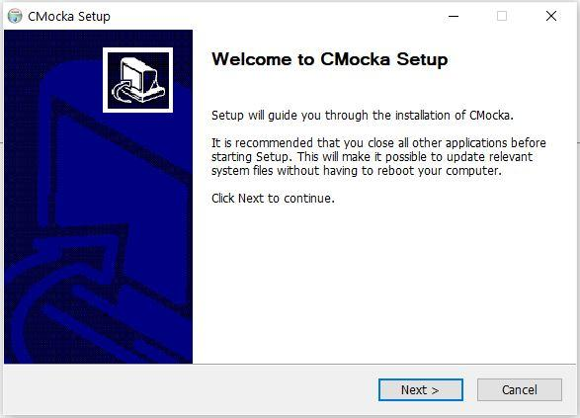
* Click “next” and click on “I Agree”.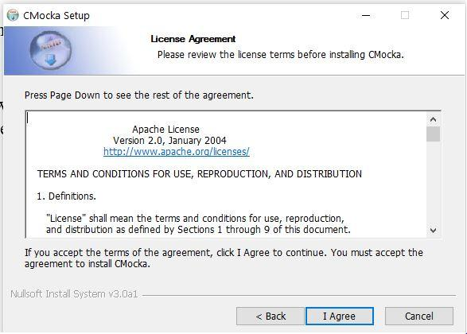
* On the next window click on “browse” and select MinGW directory as installation directory.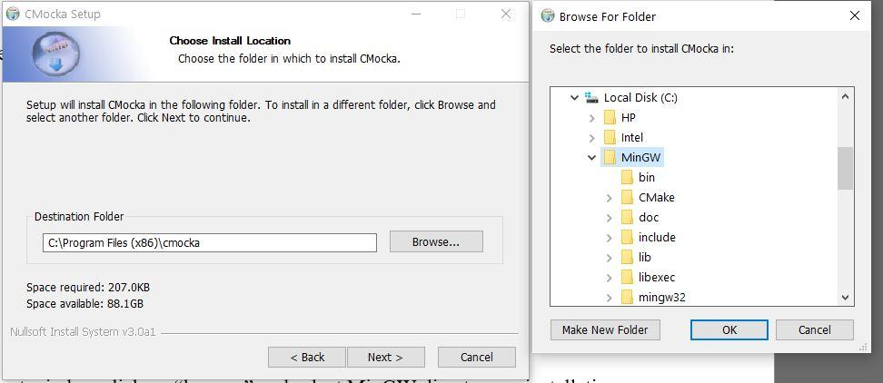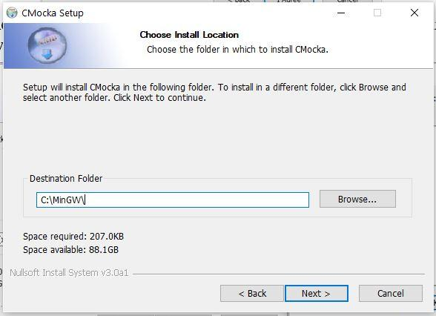
* Click “next” and click “install” and you’re done.

**How to write Test program:**

Using cmocka is very easy, follow the below example.

Str_length.c

#include <assert.h>

#include <stdlib.h>

extern void mock_assert(const int result, const char* const expression,

const char * const file, const int line);

#undef assert

#define assert(expression) \

mock_assert(((expression) ? 1 : 0), #expression, __FILE__, __LINE__);

int str_length(char *str)

{

assert(str != NULL);

int count = 0;

while(*str != '\0') {

count += 1;

str++;

}

if(count > 0)

return count;

else

return -1;

}

Suppose we want to test the above code with cmocka. In the source code assert functions should be replaced with cmocka mock_assert function, as it will abort the program. Test code for str_length.c is given below.

str_length_test.c

#include <stdlib.h>

#include <string.h>

#include <stdarg.h>

#include <stddef.h>

#include <setjmp.h>

#include <cmocka.h>

extern int str_length(char *str);

static char s[10];

void init()

{

s[0] = 'a';

s[1] = 'b';

s[2] = 'c';

s[3] = 'd';

}

void null_test(void **state)

{

expect_assert_failure(str_length(NULL));

}

void unterminated_test(void **state)

{

assert_int_equal(str_length(s), 4);

}

void terminated_test(void **state)

{

s[4] = '\0';

assert_int_equal(str_length(s), 4);

}

int main(int argc, char *argv[])

{

init();

const struct CMUnitTest tests[] = {

cmocka_unit_test(null_test),

cmocka_unit_test(unterminated_test),

cmocka_unit_test(terminated_test),

};

return cmocka_run_group_tests(tests, NULL, NULL);

}

**Test Cases:**

Math Functions:

|  |  |  |
| --- | --- | --- |
| **Function file** | **Test function file** | **How to build** |
| evenOrOdd.c | evenOrOdd_test.c | gcc evenOrOdd.c enenOrOdd_test.c -lcmocka |
| factorial.c | Factorial_test.c | gcc factorial.c factorial_test.c -lcmocka |
| factors.c | factors_test.c | gcc factors.c factors_test.c -lcmocka |
| fibonacci.c | fibonacci_test.c | gcc fibonacci.c fibonacci_test.c -lcmocka |
| FV.c | FV_test.c | gcc FV.c FV_test.c -lcmocka |
| gcd.c | gcd_test.c | gcc gcd.c gcd_test.c -lcmocka |
| is_prime.c | is_prime_test.c | gcc is_prime.c is_prime_test.c -lcmocka |
| lcm.c | lcm_test.c | gcc lcm.c lcm_test.c -lcmocka |
| nCr.c | nCr_test.c | gcc nCr.c nCr_test.c -lcmocka |
| nPr.c | nPr_test.c | gcc nPr.c nPr_test.c -lcmocka |
| power.c | power_test.c | gcc power.c power_test.c -lcmocka |
| primefactor.c | primefactor_test.c | gcc primefactor.c primefactor_test.c -lcmocka |
| PV.c | PV_test.c | gcc PV.c PV_test.c -lcmocka |

String Functions

|  |  |  |
| --- | --- | --- |
| **Function File** | **Test function file** | **How to build** |
| mem_copy.c | mem_copy_test.c | gcc mem_copy.c mem_copy_test.c -lcmocka |
| str_compare.c | str_compare_test.c | gcc str_compare.c str_compare_test.c -lcmocka |
| str_copy.c | str_copy_test.c | gcc str_copy.c str_copy_test.c -lcmocka |
| str_cpy.c | str_cpy_test.c | gcc str_cpy.c str_cpy_test.c -lcmocka |
| str_find_char.c | str_find_char_test.c | gcc str_find_char.c str_find_char_test.c -lcmocka |
| str_length.c | str_length_test.c | gcc str_length.c str_length_test.c -lcmocka |
| str_split.c | str_split_test.c | gcc str_split.c str_split_test.c -lcmocka |
| str_find_substring.c | str_find_substring_test.c | gcc str_find_substring.c str_find_substring_test.c -lcmocka |

Generic Sort Function

|  |  |  |
| --- | --- | --- |
| **Function File** | **Test function file** | **How to build** |
| gensort.c | gensort_test.c | gcc gensort.c gensort_test.c mem_copy.c -lcmocka |

Linked-list Functions

|  |  |  |
| --- | --- | --- |
| **Function File** | **Test function file** | **How to build** |
| AlternatingSplit.c | alternatingSplit_test.c | gcc AlternatingSplit.c alternatingSplit_test.c MoveNode.c -lcmocka |
| Append.c | Append_test.c | gcc Append.c Append_test.c -lcmocka |
| count.c | count_test.c | gcc count.c count_test.c -lcmocka |
| countNode.c | countNode_test.c | gcc countNode.c countNode_test.c -lcmocka |
| DeleteList.c | DeleteList_test.c | gcc DeleteList.c DeleteList_test.c -lcmocka |
| FrontBackSplit.c | FrontBackSplit_test.c | gcc FrontBackSplit.c FrontBackSplit_test.c countNode.c -lcmocka |
| GetNth.c | GetNth_test.c | gcc GetNth.c GetNth_test.c -lcmocka |
| InsertNth.c | InsertNth_test.c | gcc InsertNth.c InsertNth_test.c -lcmocka |
| InsertSort.c | InsertSort_test. | gcc InsertSort.c InsertSort_test.c SortedInsert.c -lcmocka |
| MergeSort.c | MergSort_test.c | gcc MergSort_test.c MergeSort.c FrontBackSplit.c SortedMerge.c MoveNode.c countNode.c -lcmocka |
| MoveNode.c | MoveNode_test.c | gcc MoveNode.c MoveNode_test.c -lcmocka |
| newNode.c | newNode_test.c | gcc newNode.c newNode_test.c -lcmocka |
| pop.c | pop_test.c | gcc pop.c pop_test.c -lcmocka |
| push.c | push_test.c | gcc push.c push_test.c -lcmocka |
| RemoveDuplicates.c | RemoveDuplicates_test.c | gcc RemoveDuplicates.c RemoveDuplicates_test.c -lcmocka |
| Reverse.c | Reverse_test.c | gcc Reverse.c Reverse_test.c -lcmocka |
| ShuffleMerge.c | ShuffleMerge_test.c | gcc ShuffleMerge.c ShuffleMerge_test.c MoveNode.c -lcmocka |
| SortedInsert.c | SortedInsert_test.c | gcc SortedInsert.c SortedInsert_test.c -lcmocka |
| SortedIntersect.c | SortedIntersect_test.c | gcc SortedIntersect.c SortedIntersect_test.c push.c -lcmocka |
| SortedMerge.c | SortedMerge_test.c | gcc SortedMerge.c SortedMerge_test.c MoveNode.c -lcmocka |